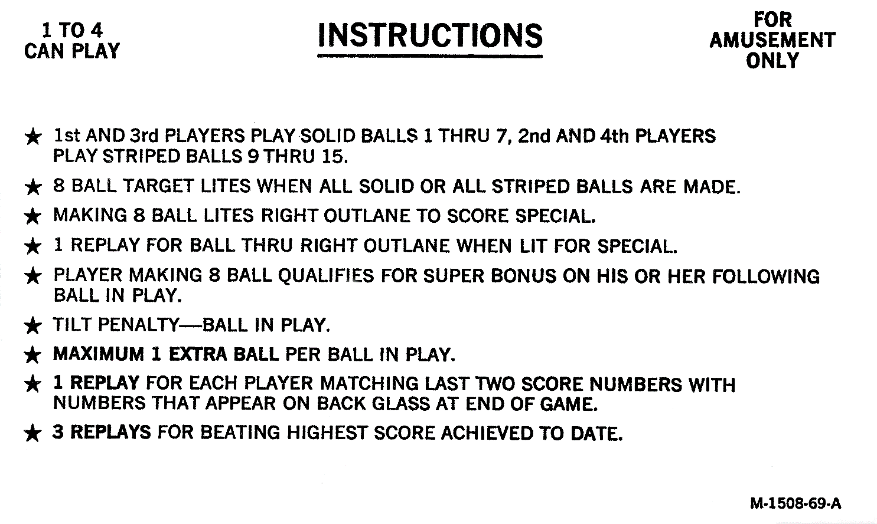

* **GOALS TOTAL (6 POSSIBLE) APPEARS IN PLAYER SCORE SINGLES DIGIT.**
* **SUPER BONUS AFTER CAPTURING ALL 8 BALLS, GAINED ON NEXT NEW BALL.**
* **CAPTURING 2 BALLS IN SEQUENCE AWARDS ‘NEXT BALL’ SCORE – 5000 PTS FOR EACH BALL IN ORDER.**
* **BALL-IN-PLAY DISPLAY COUNTS DOWN TO POP MODE FOR INCREASED SCORING – 1000 PTS, THEN 2000 PTS.**
* **CREDIT DISPLAY COUNTS DOWN TO SPINNER MODE FOR INCREASED SCORING – 1500 THEN 2000 PTS WHEN LIT.**
* **REACH SPINNER MODE TWICE TO START SPINNER COMBO, MAKE BANK SHOT THEN SPINNER BEFORE TIMER RUNS OUT – 25000 PTS.**
* **ACHIEVE POP MODE TO UNLOCK BALL SCRAMBLE MODE. HIT TOP LEFT STAND-UP TO SCRAMBLE CAPTURED BALLS – 2500 PTS.**
* **ACHIEVE ANY 3 GOALS TO ENTER BALL CHASE MODE - TIMED EVENT TO CAPTURE UP TO 2 BALLS 5000, 20000 PTS.**
* **ACHIEVE ANY 5 GOALS TO ENABLE 15 BALL MODE – CAPTURE BALLS 1-7, 9-15 THEN 8 BALL. EACH BALL AWARDS 5000 PTS, LOSING A BALL -10000 PTS. BONUS IS DOUBLED. EIGHT BALL AWARDS 100,000 PTS**

**M-1508-69-B**